The Presidential Chair

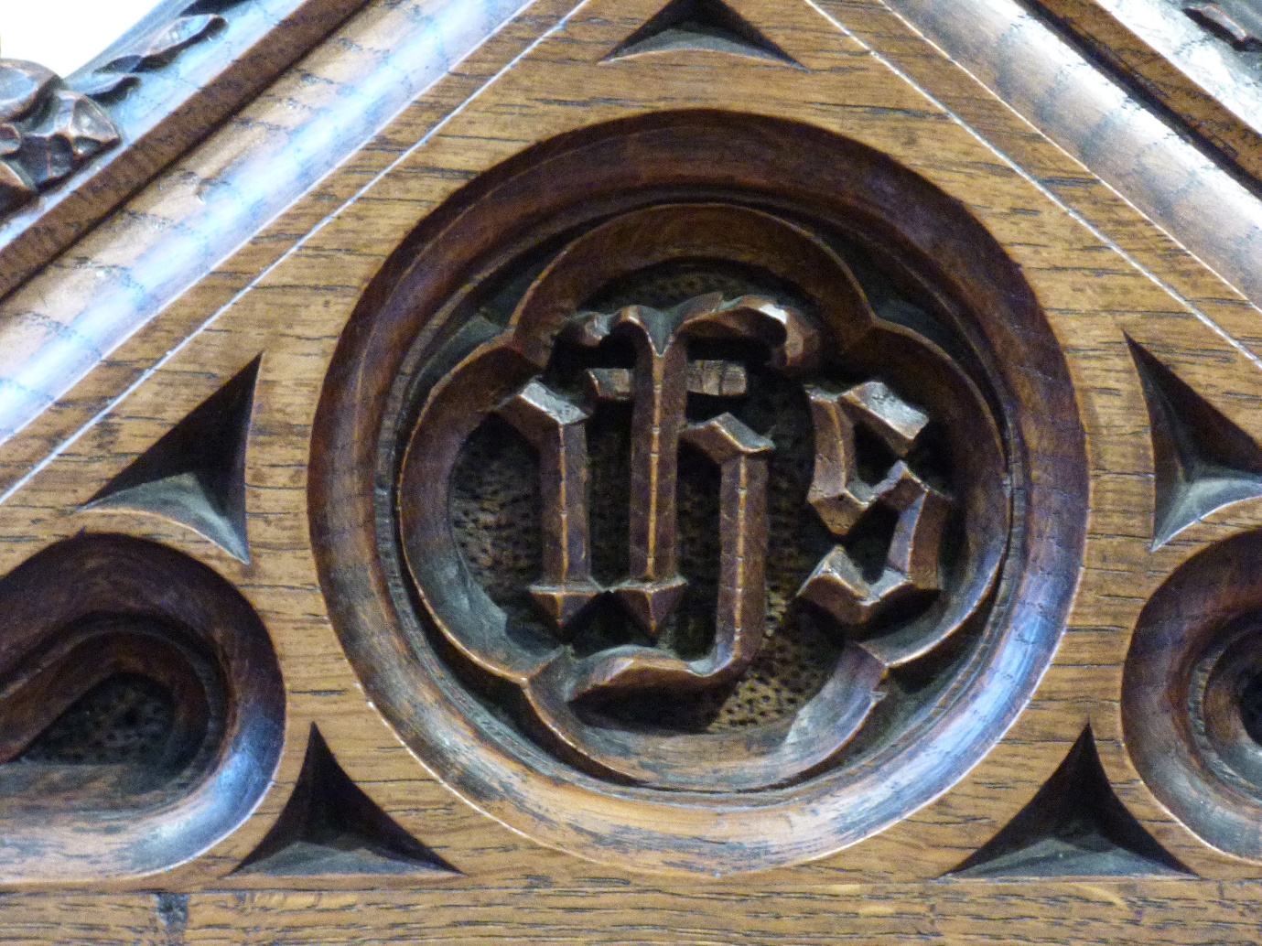

This detail is from the presidential chair on the altar. IHS are the first 3 letters of Jesus’ name in Greek.

