The Lady Chapel

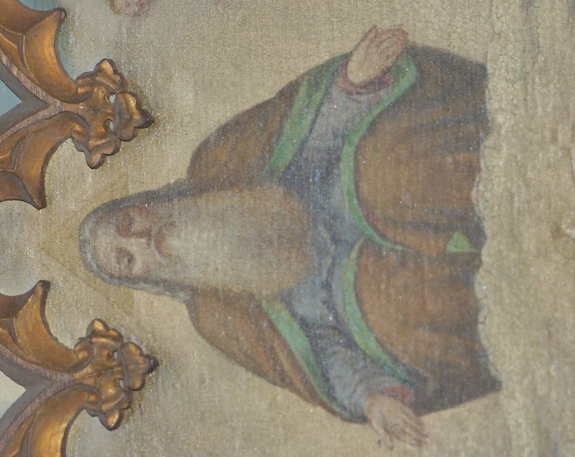

This image of God is at the top of the painting of the annunciation, on the altar in the Lady Chapel.
