Pelicans

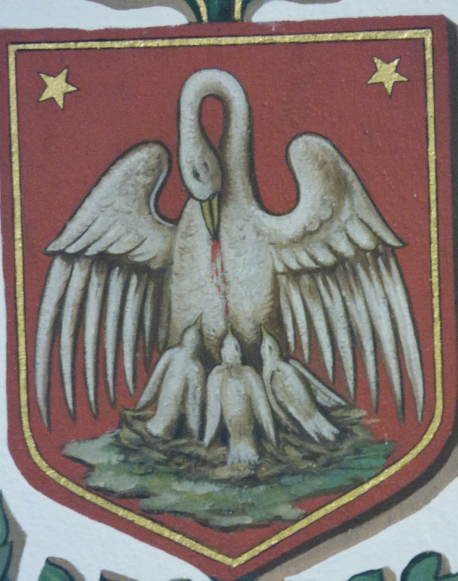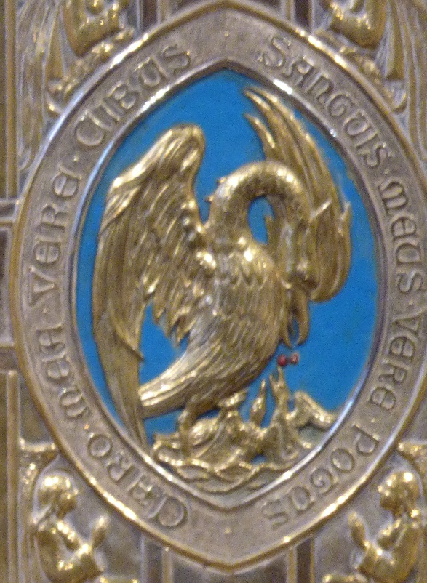

The image on the left is painted high on the wall to the left of the altar. The one on the right is the door of the tabernacle. The image of the pelican represents Christ, because of the tradition that the pelican uses her own blood to feed her young.

